**Decision tree visualization for German Credit Dataset**

**step 1**: Open weka Explorer

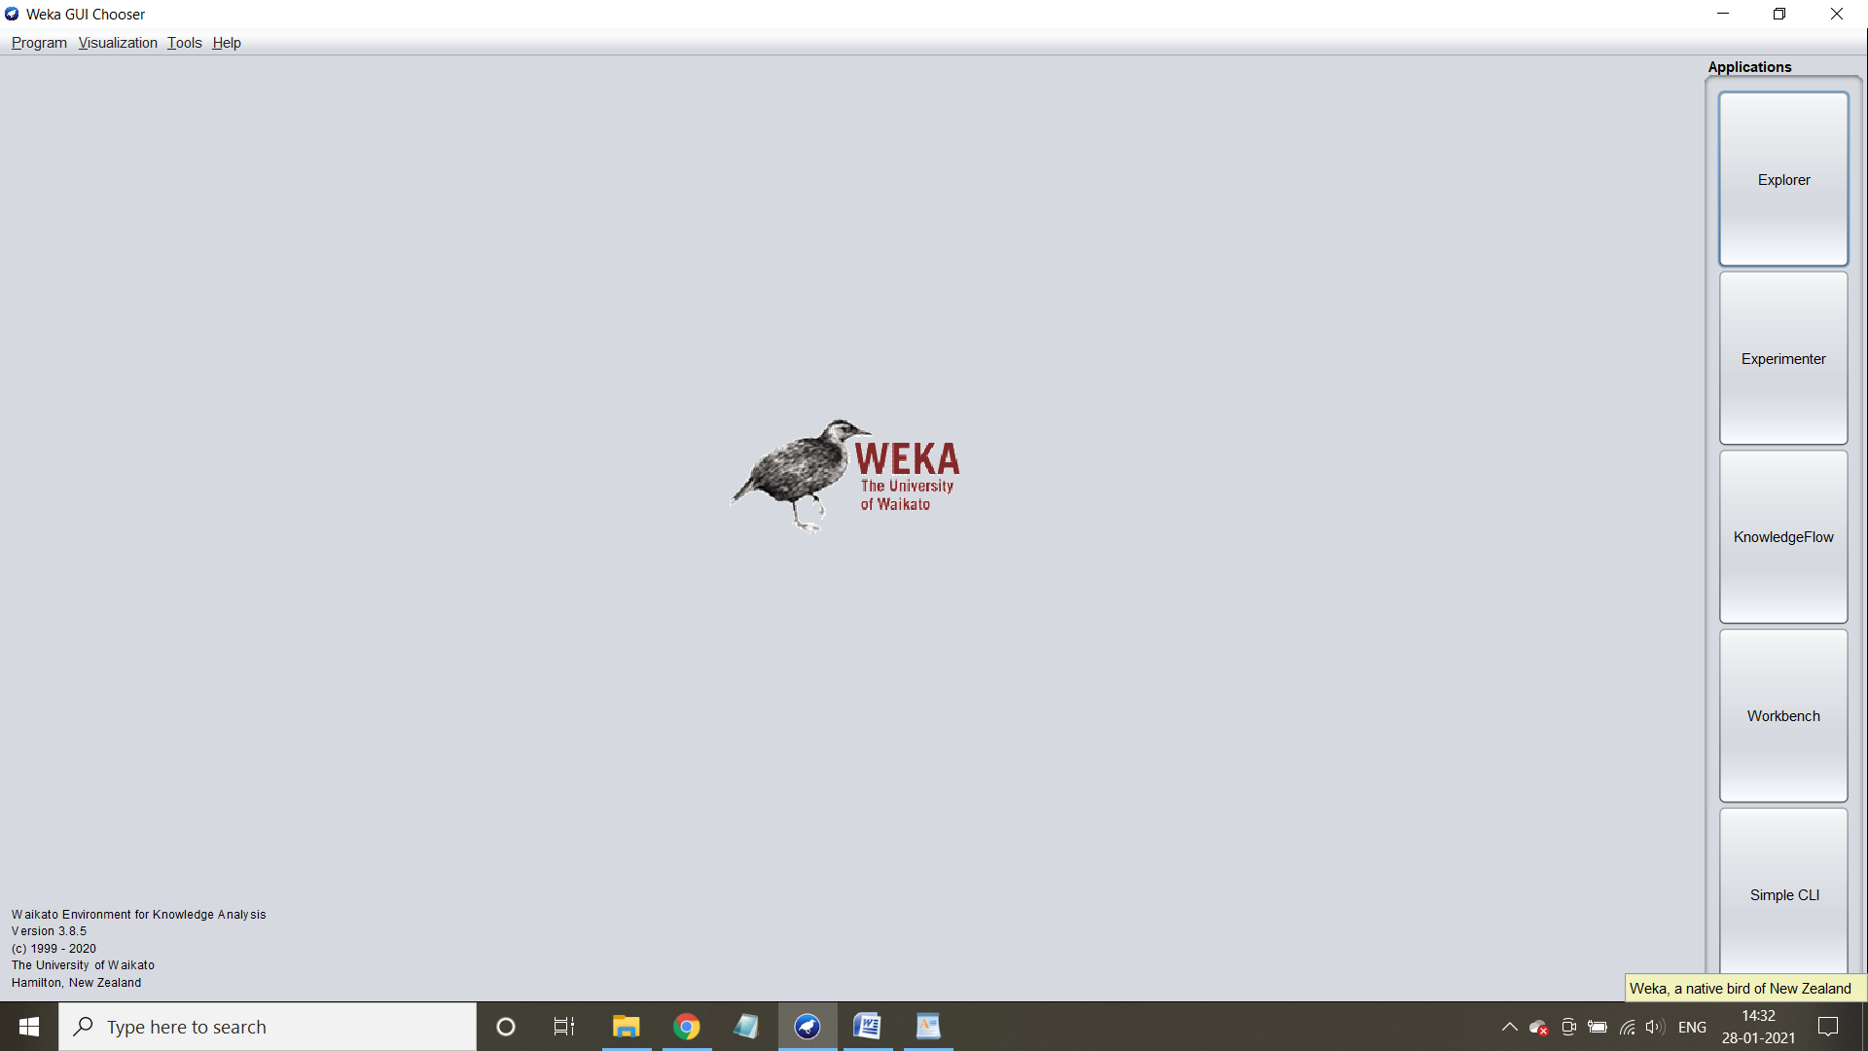

**Step 2**: Load the dataset into Weka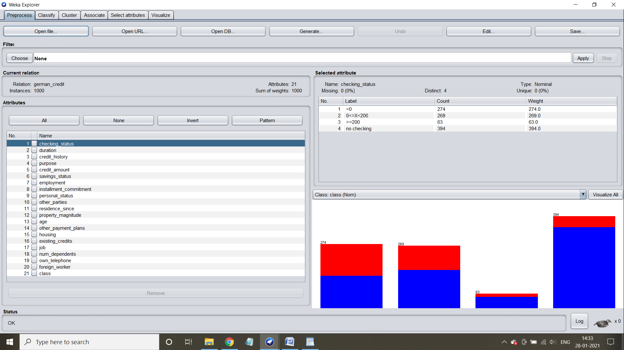

**Step 3**: Select Class attribute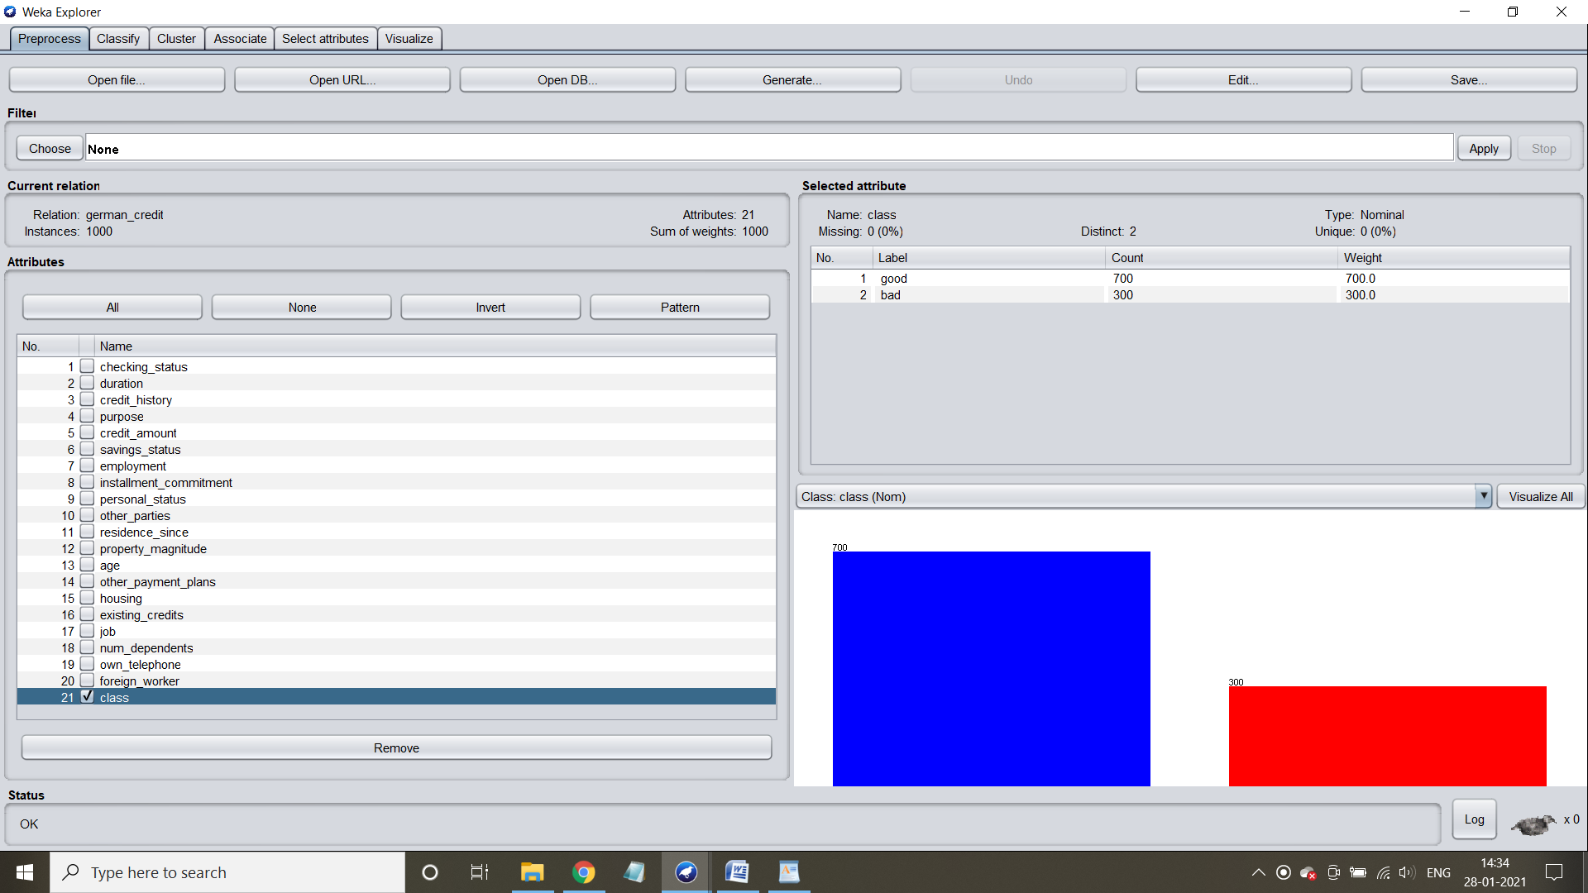

**Step 4**: Go to “Classify” tab and select “use training set” and select choose button and select J-48 in the tree section, to generate a decision tree. Hit the start button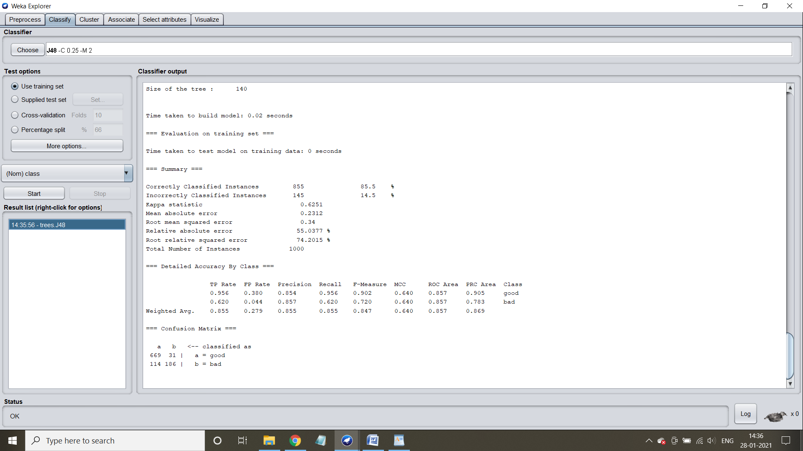

Step 5: Check the characteristics of tree generated

**Case 1: For application of J-48**

Number of Leaves : 103

Size of the tree : 140

Time taken to build model: 0.02 seconds

Confusion matrix and accuracy of the decision tree: 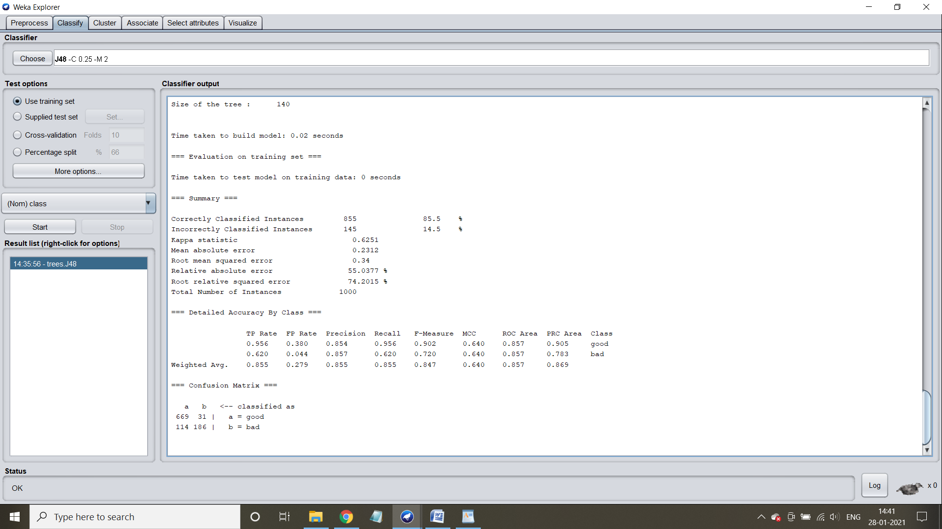

**Visualization of decision tree:­­­­­­**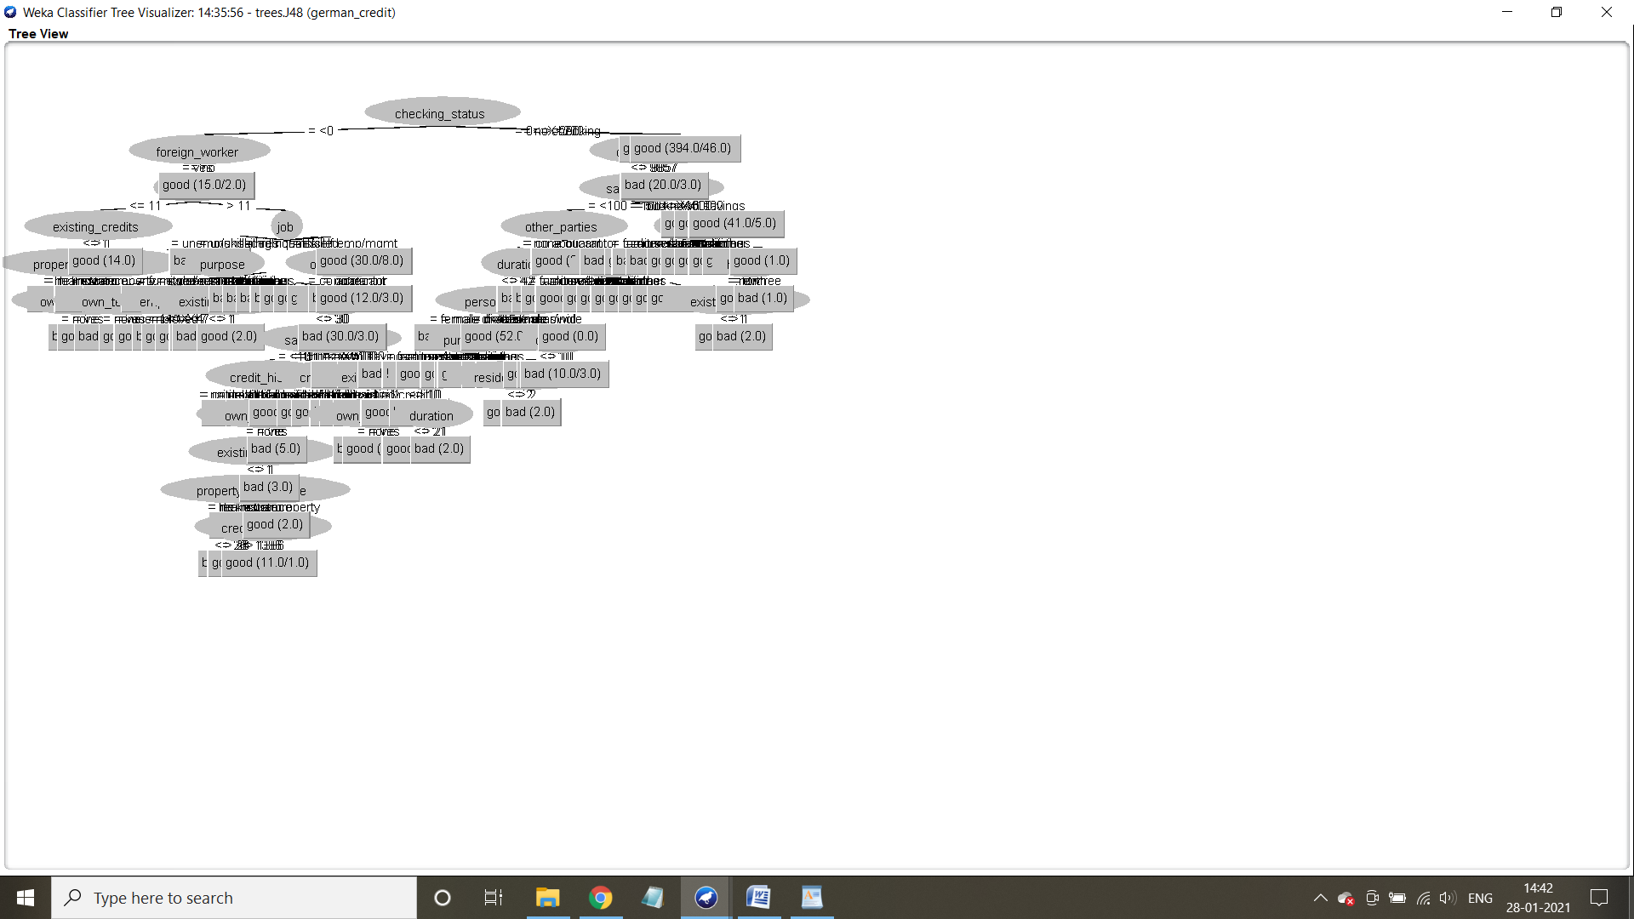

**Application of cross-validation**

Case 1: Number of folds = 10

Step 1: Select cross validation option and in number of folds, give 10 and hit start button

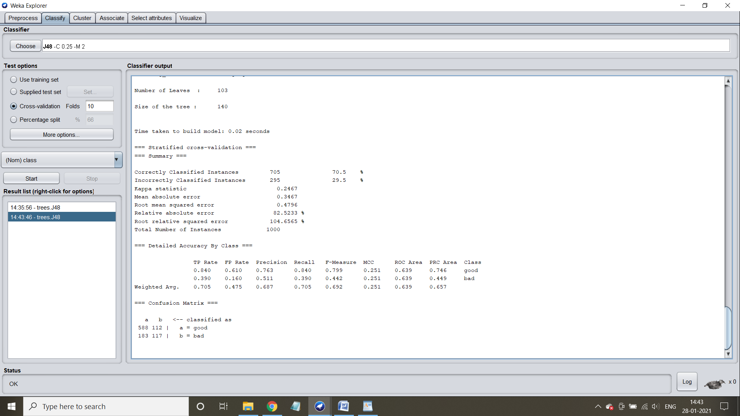

Step 2: Understand the characteristics of the tree generated

Number of leaves : 103

Size of tree :140

Time taken: 0.02 seconds

Confusion matrix and accuracy: 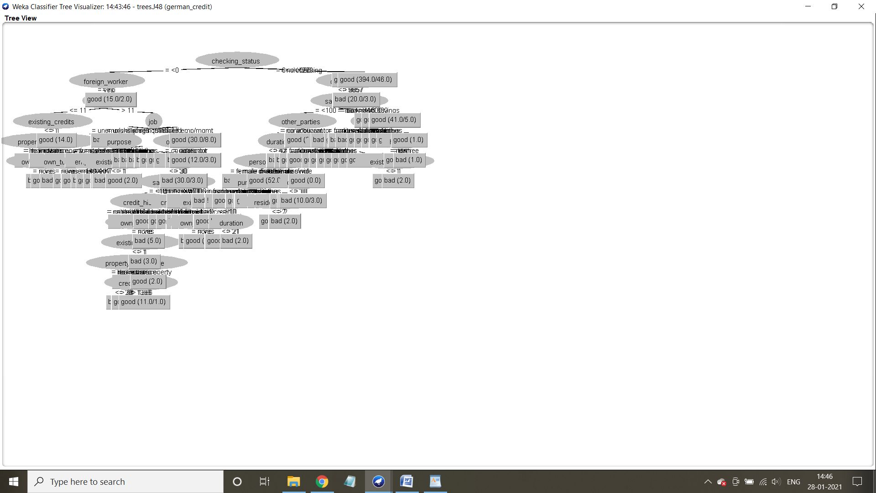

Step 3: Visualize the decision tree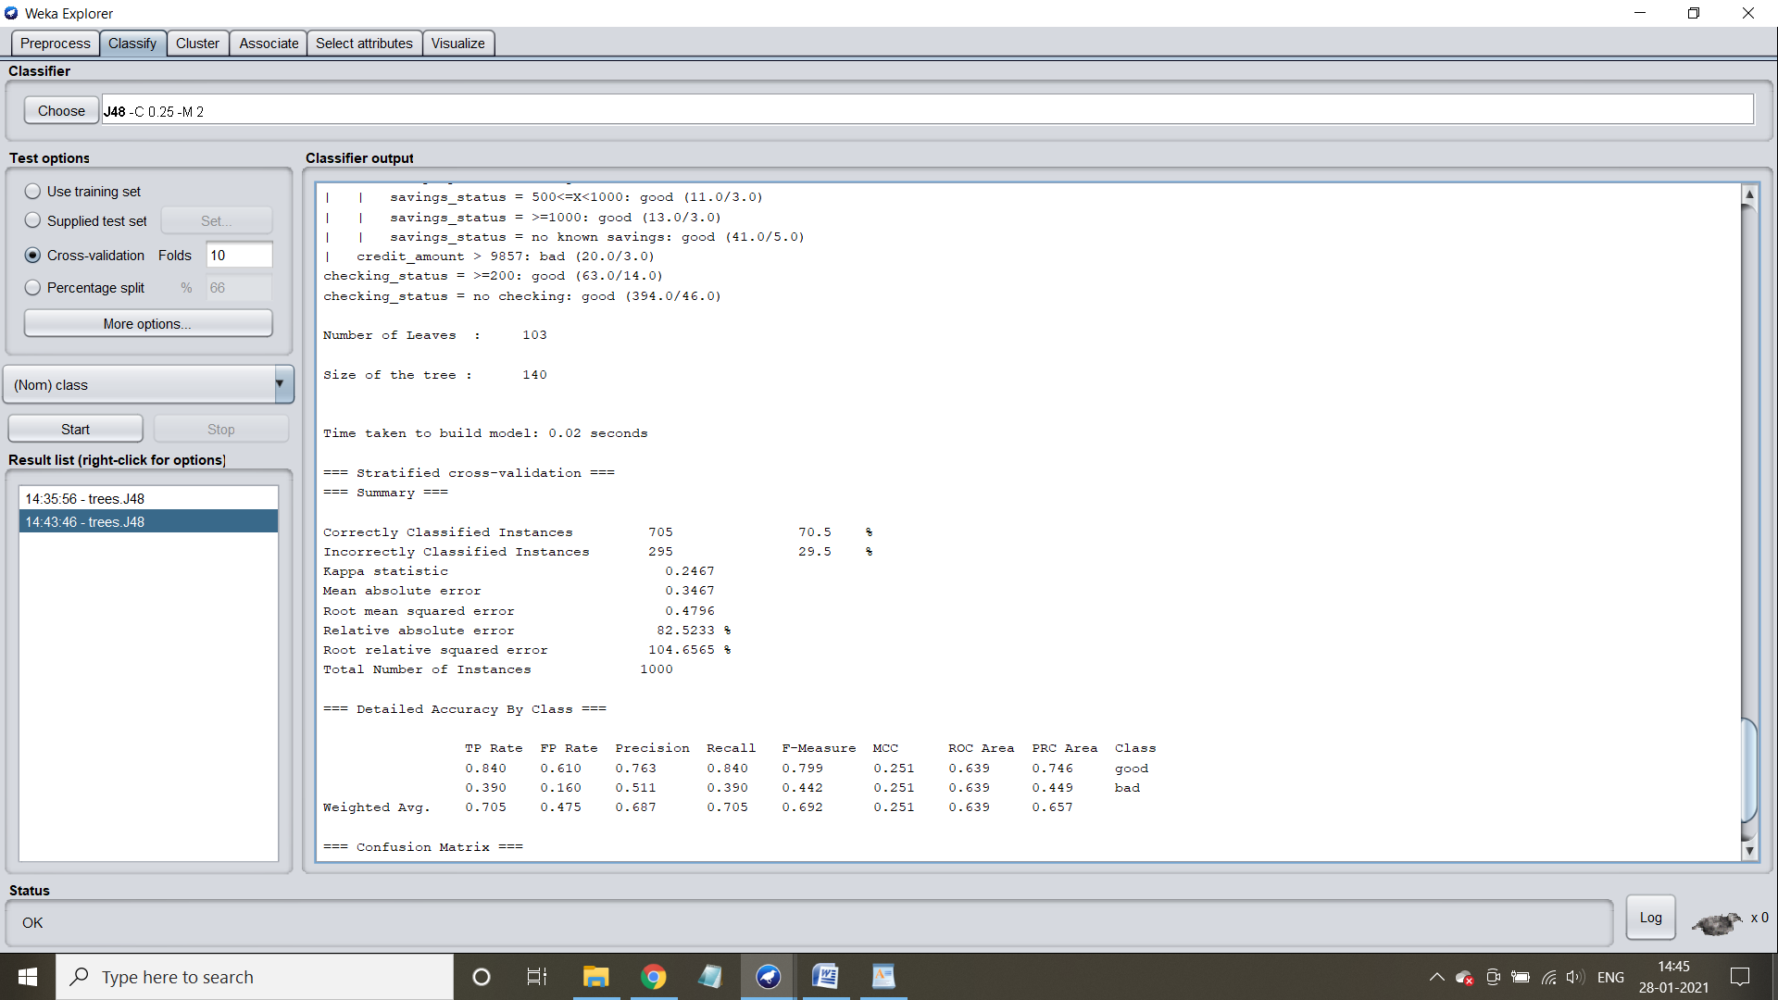

Case 2: Number of folds = 8

Specify the number of folds as 8

Accuracy and confusion matrix:

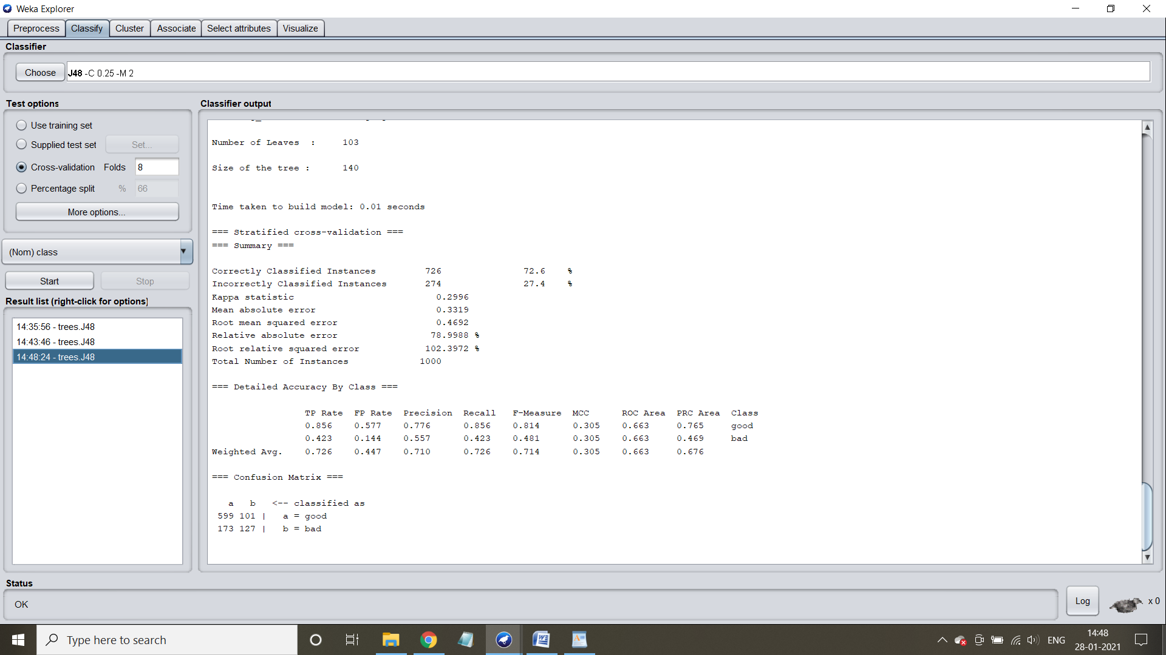

Number of leaves : 103

Size of tree: 140

Time taken:0.01 seconds

Visualize the tree: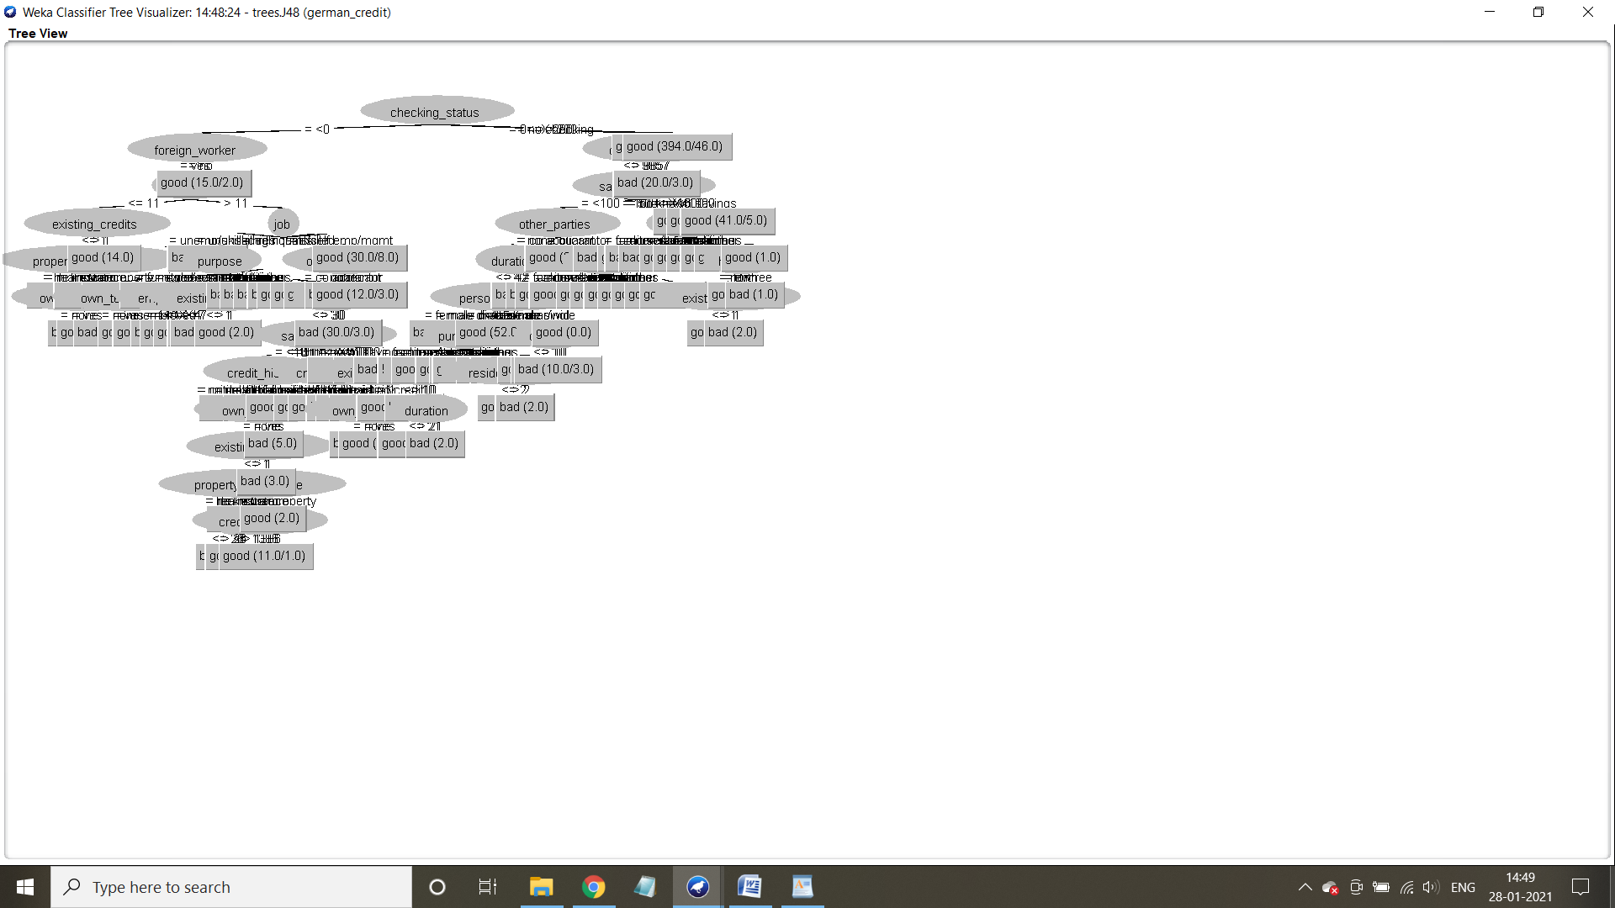

**Application of percentage split**

Case 1: When the split percentage is 70%

**Step 1:** Select the percentage split and specify 70 and hit start button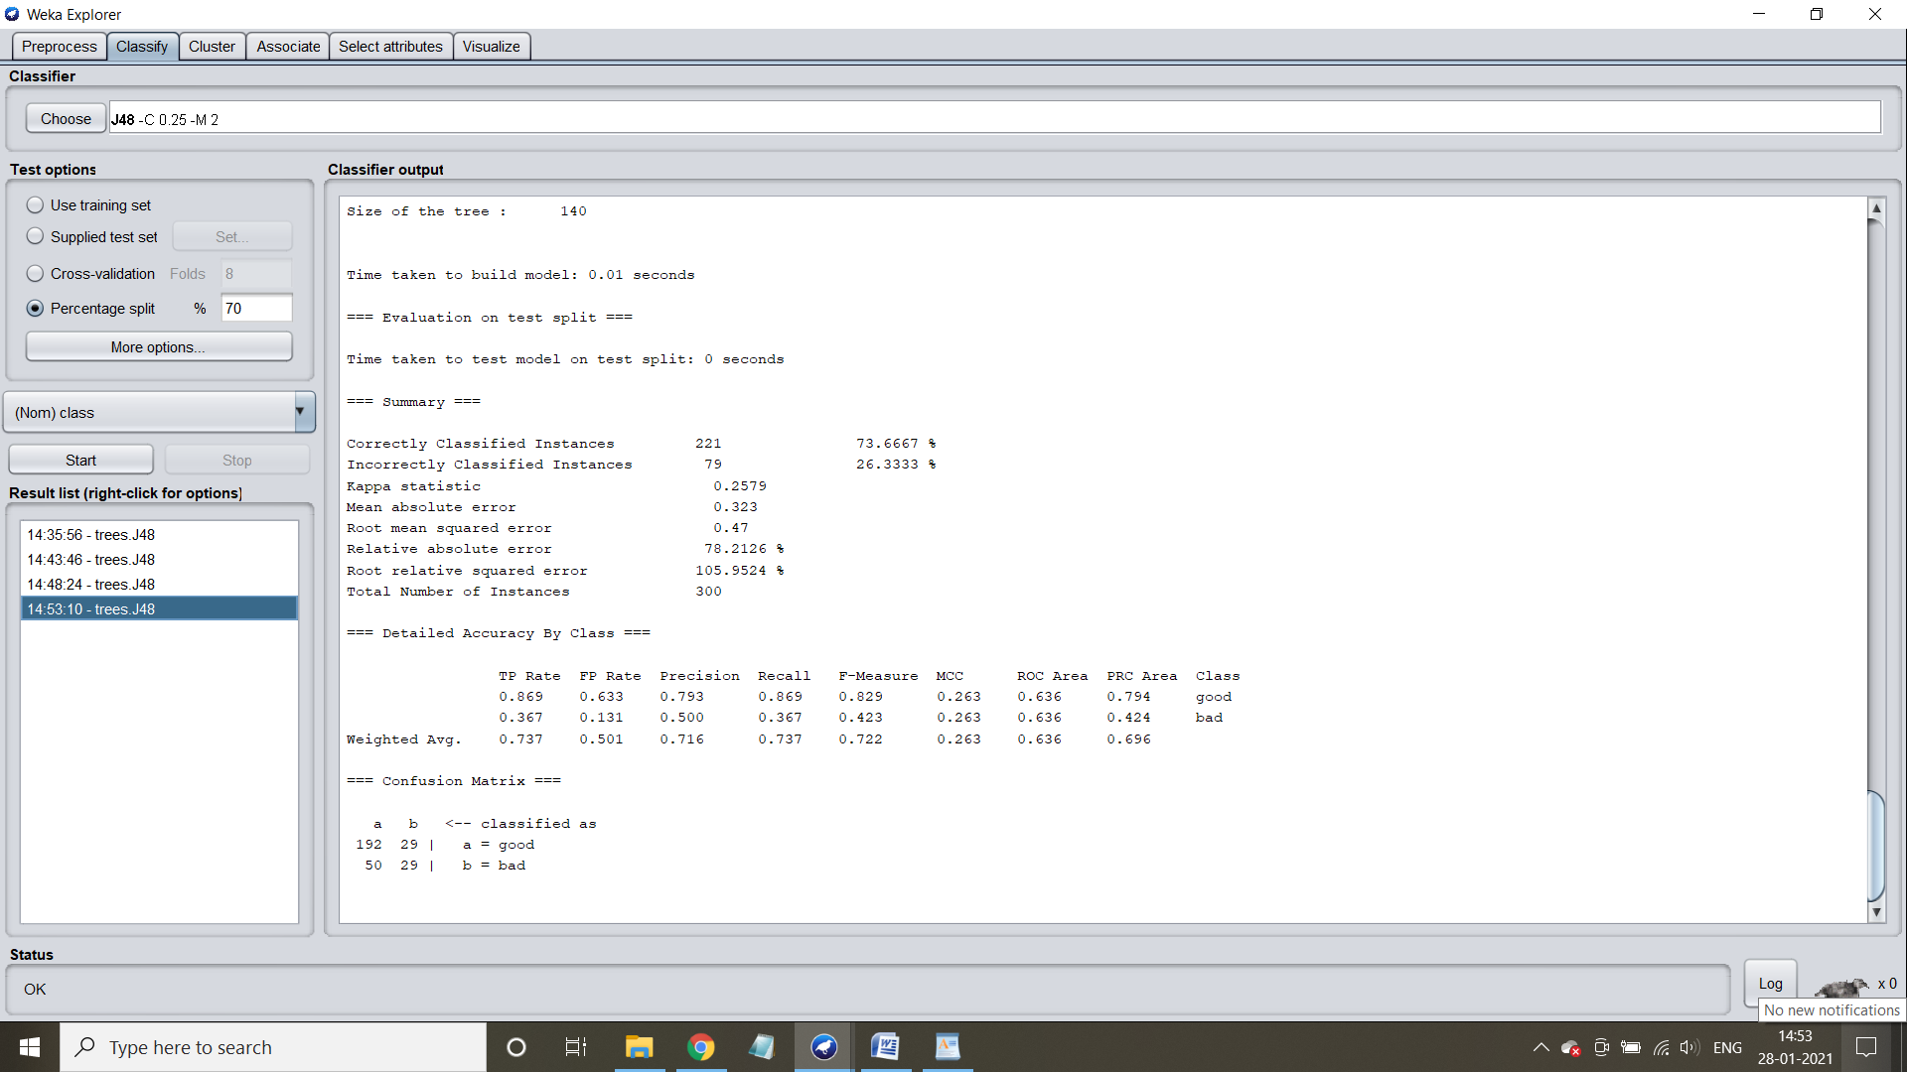

Characteristics :

Number of leaves: 103

Size of tree: 140

Time taken:0.01 seconds

Confusion matrix:

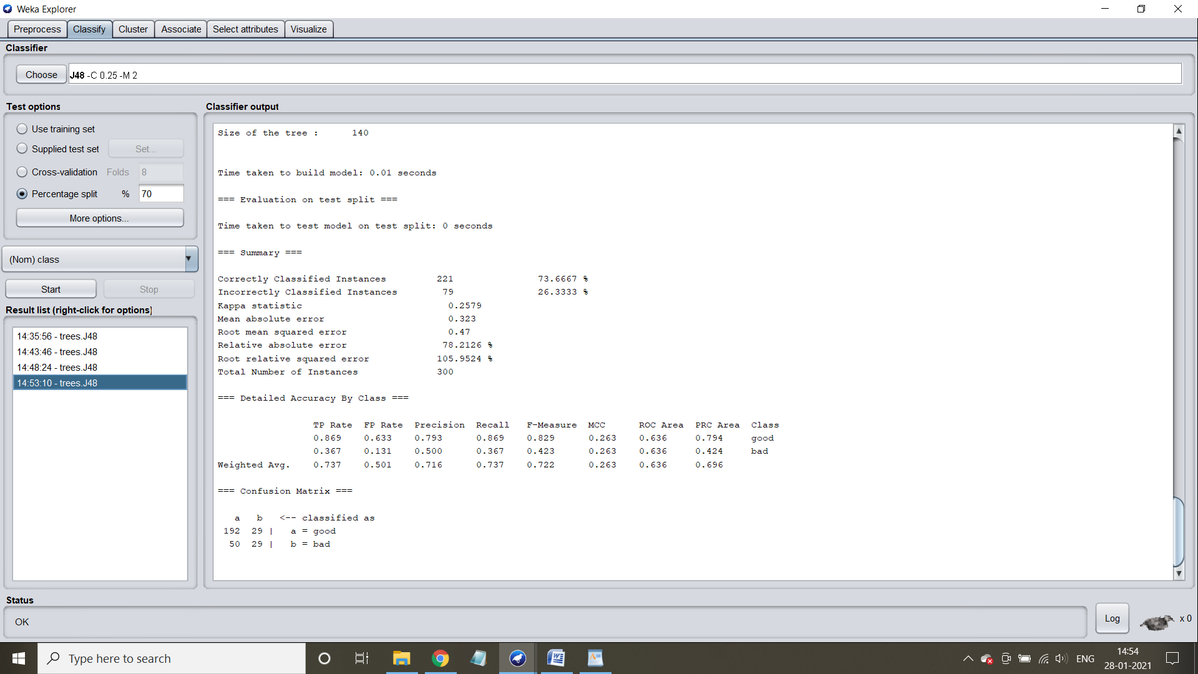

Visualize the tree:

